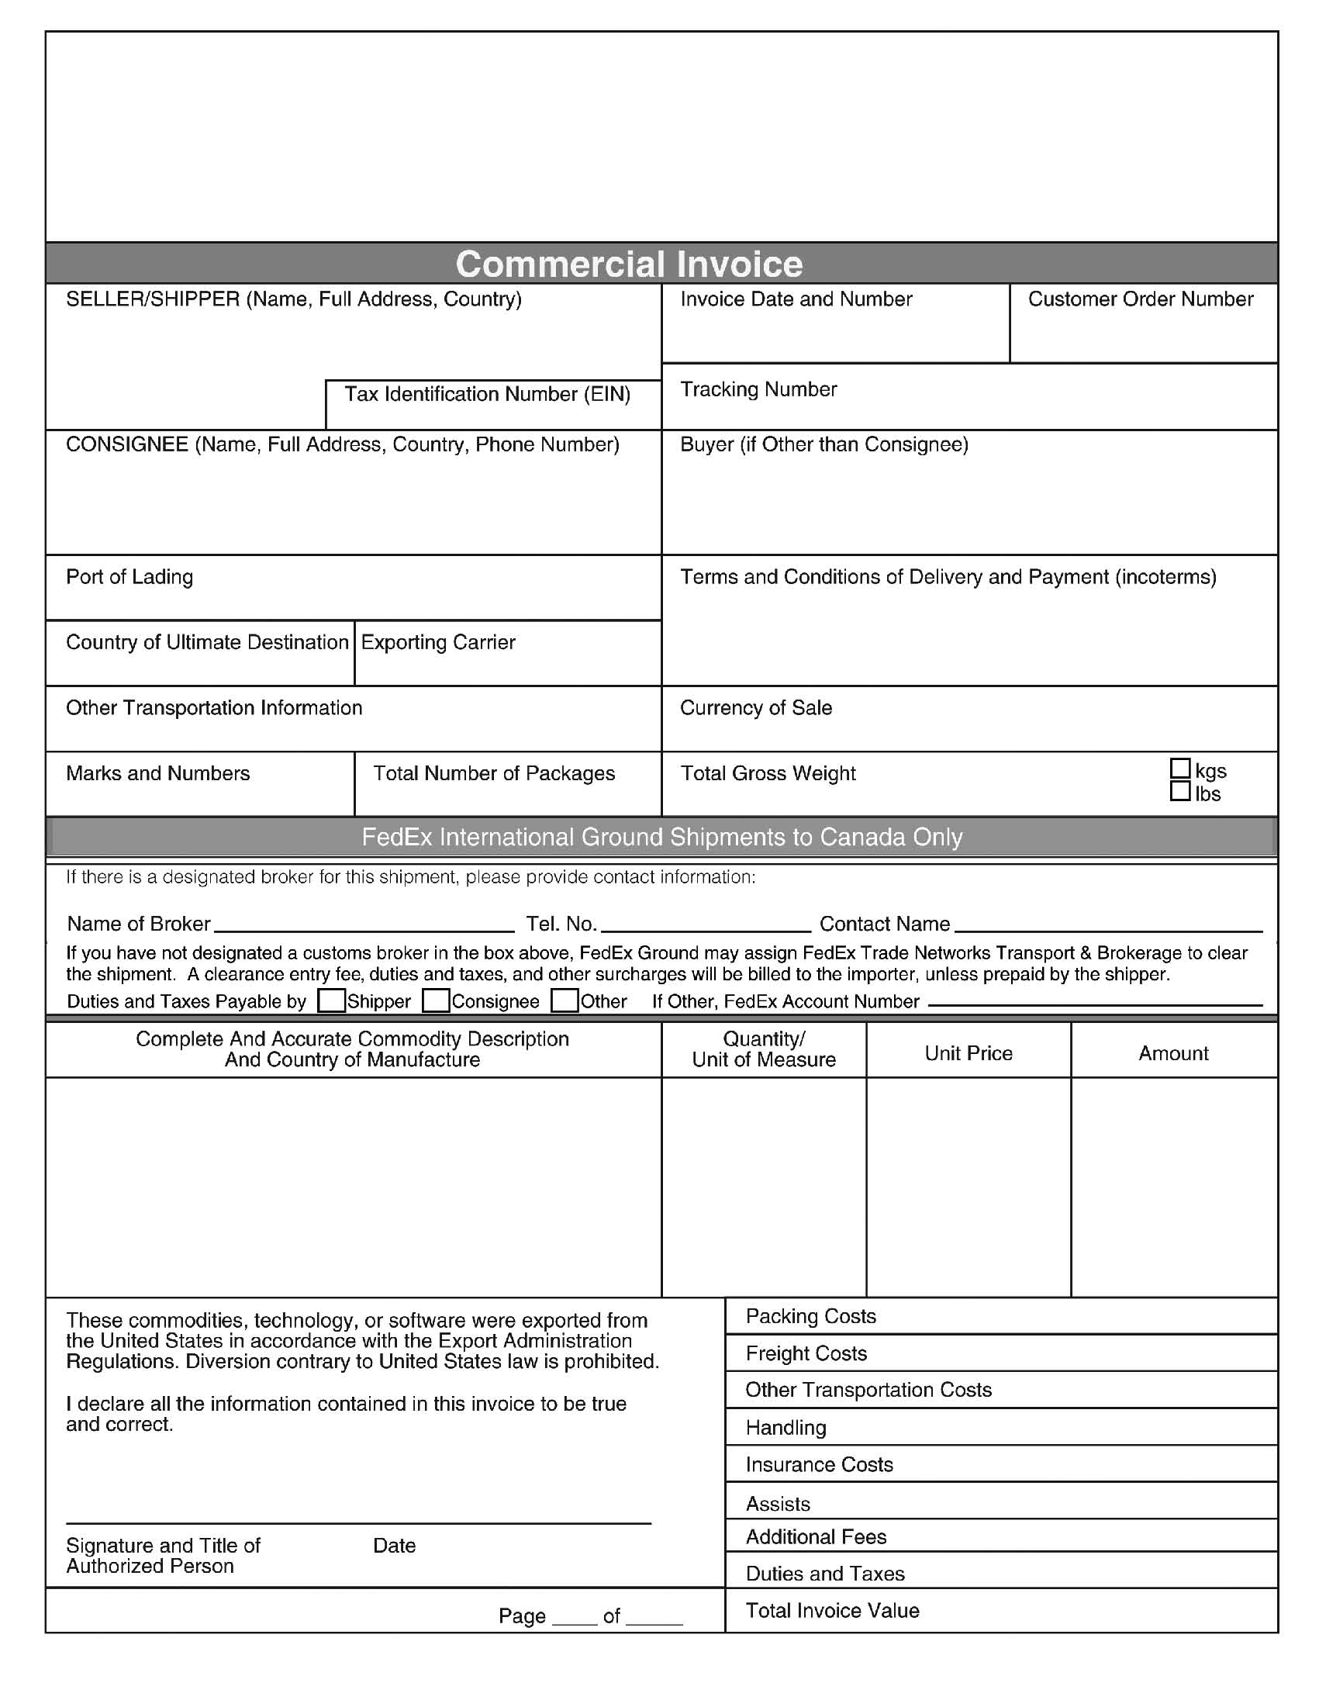
38-3232981
01-24101-001
Lansing, MI

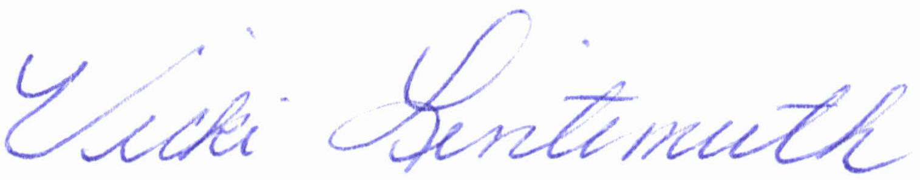
Axiom Requisition Copy Service
2869 Jolly Rd
Okemos, MI 48864
Michigan Regional Council of Carpenters Pension Fund
3800 Woodward Avenue
Detroit, MI 48226
**FILL IN COUNTRY**
FedEx

USD
1
1.0
1/20/2012 03:54:00 PM
X
1 1
****Print 5 copies to be presented to FedEx w/package

